Array Of Products. (Medium)

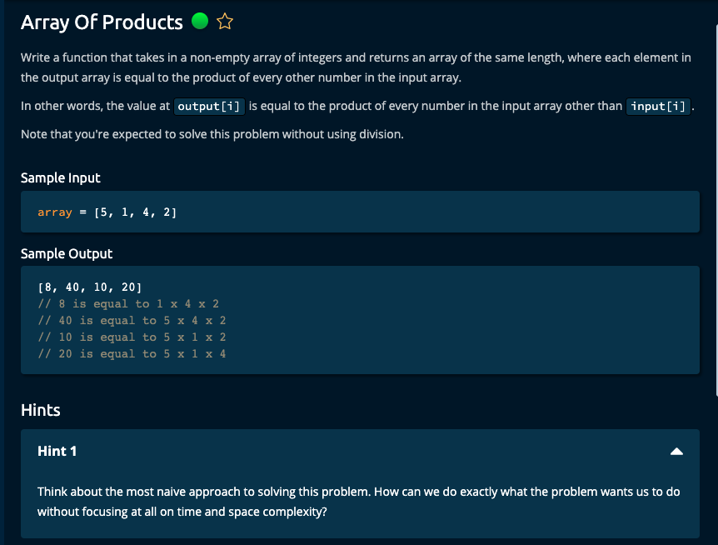

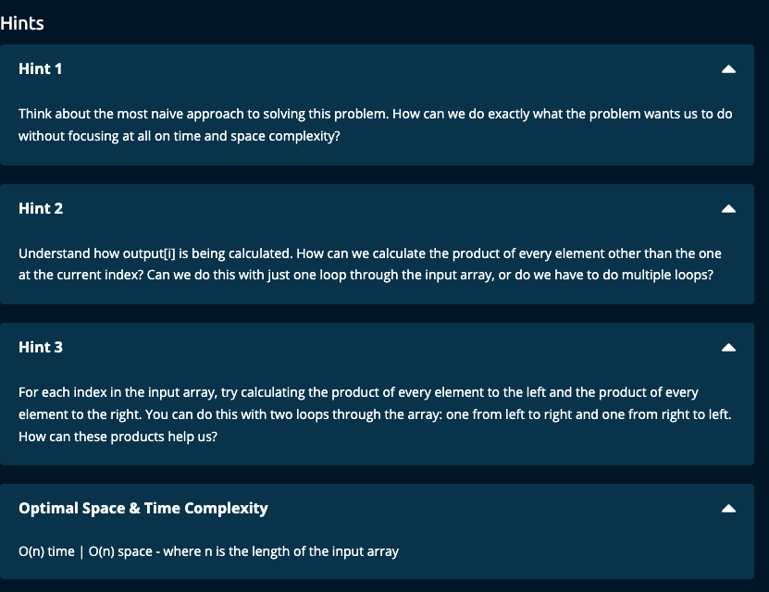

My Solution:

Solution 1:

Brute Force Method:

def arrayOfProducts(array):

n = len(array)

result = []

for i in range(n):

prod = 1

for j in range(n):

if j != i:

prod *= array[j]

result.append(prod)

return result

Solution 2:

1. Initialize an array called products to hold the result array, left product array, and right product array.
2. Initialize left running product to 1, i.e., leftProd = 1
3. Traverse through array and get the left products. Update the products array with the left products.
4. Initialize right running product to 1, i.e., rightProd = 1
5. Traverse through array in the reverse direction and get the right products. Update the products array with the right running product.
6. Finally return the products array.

def arrayOfProducts(array):

n = len(array)

leftProd = [1] * n

rightProd = [1] * n

result = [1] * n

# Get the left product

prod = 1

for i in range(n):

leftProd[i] = prod

prod *= array[i]

#Get the right product

prod = 1

for j in range(n - 1, -1, -1):

rightProd[j] = prod

prod *= array[j]

for i in range(n):

result[i] = leftProd[i] * rightProd[i]

return result

----------------------------------------------

Solution 3:

1. Initialize an array called products to hold the result array called leftProd.
2. Initialize left running product to 1, i.e., leftProd = 1
3. Traverse through array and get the left products. Update the products array with the left products.
4. Initialize right running product to 1, i.e., rightProd = 1
5. Traverse through array in the reverse direction and get the right products. Update the products array with the right running product.
6. Finally return the products array, i.e., leftProd

def arrayOfProducts(array):

n = len(array)

leftProd = []

# get the left product

prod = 1

for i in range(n):

leftProd.append(prod)

prod *= array[i]

prod = 1

for j in range(n - 1, -1, -1):

leftProd[j] *= prod

prod *= array[j]

return leftProd

Algoexpert gave these solutions.